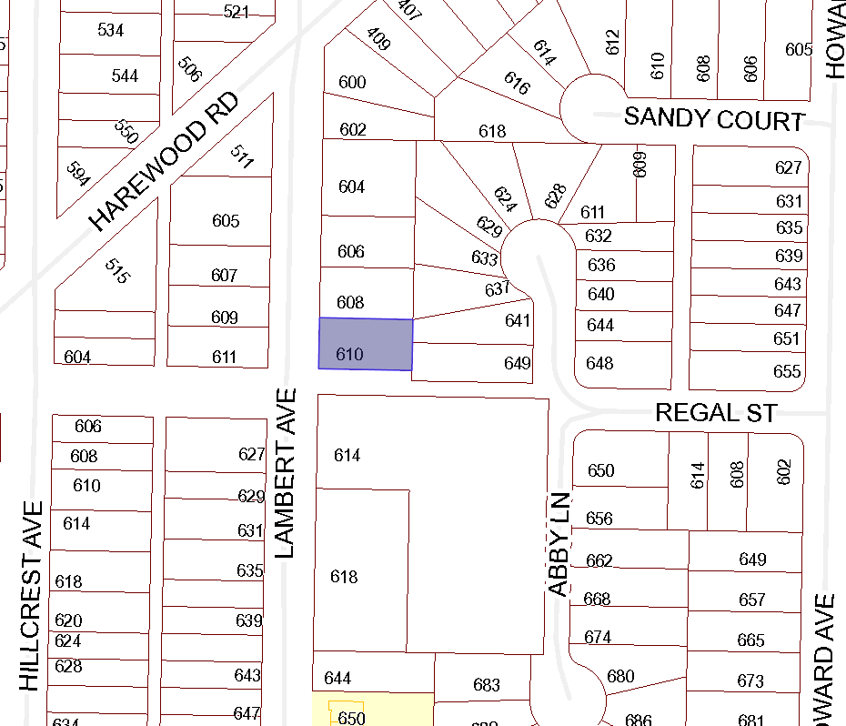

BOARD OF VARIANCE APPLICATION BOV00668

LOCATION MAP

CIVIC: 610 LAMBERT AVENUE

LEGAL: LOT 3, SECTION 1, NANAIMO DISTRICT, PLAN 10716

